Practical 18 GUI Builder
- Create the last labs one button gui using WindowBuilder. Go New |Other |WindowBuilder |Swing Designer | JFrame

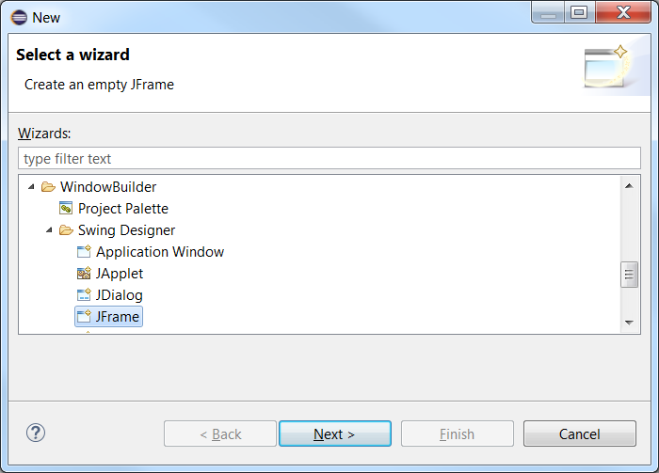

After I have dropped a panel and a button on the form, I examine my constructor code and I find an anonymous inner class. Note that the OneButtonGui class does not contain an implements statement.
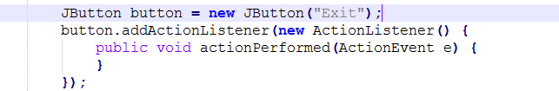

Notice also the button’s scope, it is not a class property. Both of these code preferences can be changed in
Window|Preferences|WindowBuilder|Swing|Code Generation and Event Handlers
- Create a Simple Calculator using Windows Builder
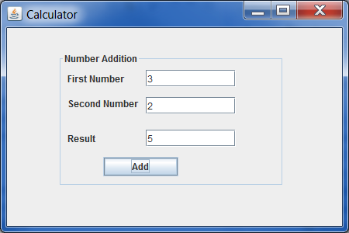
- Modify your program in part 1 to function as displayed
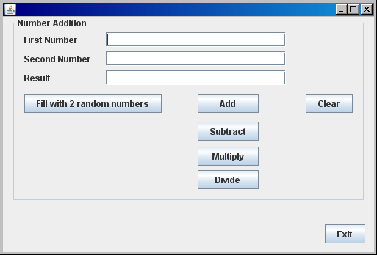

- Use the GUI builder to create the following form.
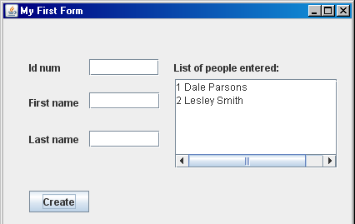

Tricky!
First click on a JScrollPane click and drag onto the form, then click a JTextArea inside it
Or
Drag and drop a JTextArea then right click on it and select “surround with” choose a JScollPane

- Start designing your form for assignment 1. Ask for help if your project is not yet reading from file.

